

A Course End Project Report on

Superposition Theorem Verifier for Multi-Source DC Circuits

A9205 – Basic Electrical Engineering Laboratory (VCE-R25)

Submitted by

Rithika Yadav 25881A05AV
C. Shravya 25881A05BP
G. Sankeerthana 25881A05BF

Dr. S. Ravi Varman
Department of Electrical and Electronics Engineering

Department of Electrical and Electronics Engineering Vardhaman College of Engineering, Hyderabad
April 2026

Contents
Abstract 2
- Introduction 3
- Theory Background 3
  - Superposition Theorem 3
  - Node Voltage Method 3
  - Ohm’s Law 3
  - Kirchhoff’s Current Law (KCL) 4
- Mathematical Formulation 4
  - Circuit Topology 4
  - Variables and Assumptions 4
  - Step 1 – V1 Acting Alone (V2 Shorted) 5
  - Step 2 – V2 Acting Alone (V1 Shorted) 5
  - Step 3 – Superposition (Algebraic Sum) 5
  - Step 4 – Actual Circuit (Node Voltage Method) 5
  - Power Analysis 5
- Algorithm / Flowchart 5
  - Algorithm 5
  - Flowchart 7
- Program Code 7
  - Language and Libraries 7
  - Source Code 7
- Sample Inputs and Outputs 10
  - Test Case – Sample Values 10
  - Console Output – Steps 1 & 2 11
  - Console Output – Verification Table & Power Analysis 11
  - Computed Results Summary 12
- Graphs 12
- Result Analysis 13
  - Numerical Verification 13
  - Conservation of Energy 13
  - Sensitivity Analysis 13
  - Mapping to Program Outcomes (POs) 14
  - Mapping to Sustainable Development Goals (SDGs) 14
- Conclusion 14
References 16

Abstract
Traditional methods of verifying circuit theorems rely on physical hardware experimentation, which demands expensive components and laboratory time. This project presents a programming-based analytical model to verify the Superposition Theorem for multi-source DC circuits using Python. The program accepts user-defined values of two voltage sources (V1, V2) and three resistors (R1, R2, R3) connected in a standard topology, then systematically computes branch currents and node voltages by activating each source independently. The superposed results are subsequently compared with those obtained via the Node Voltage Method to confirm theorem validity.
The system performs complete numerical verification, displays step-by-step computation, validates results against direct analysis, and generates graphical outputs including a compari-son bar chart and a sensitivity analysis curve. The project aligns with Units I–V of the BEE syllabus and demonstrates how computational tools can supplement theoretical and experimen-tal understanding of fundamental electrical engineering principles.
Keywords: Superposition Theorem, DC Circuit Analysis, Node Voltage Method, Python, Matplotlib, Numerical Verification.

Introduction
Circuit theorems form the backbone of electrical engineering analysis. Among them, the Su-perposition Theorem is one of the most powerful tools for analysing linear circuits containing multiple independent sources. While textbook derivations and laboratory experiments are in-valuable, computational verification provides an additional layer of rigour, repeatability, and insight.
This project implements a Python-based analytical model that:
Accepts arbitrary circuit parameters (sources and resistances) as user inputs.
Applies the Superposition Theorem step-by-step, deactivating each source in turn.
Independently solves the circuit using the Node Voltage Method as the ground truth.
Compares both results numerically and confirms theorem correctness.
Generates publication-quality graphs including a bar chart comparison and a sensitivity analysis.
The project is developed under the guidelines of Course A9205 – Basic Electrical Engineering Laboratory (VCE-R25), I B.Tech. II Semester, CSE-F, Academic Year 2025–2026.

Theory Background

Superposition Theorem
The Superposition Theorem states that in a linear bilateral network containing multiple inde-pendent sources, the response (current or voltage) in any branch is equal to the algebraic sum of the responses produced by each independent source acting alone, while all other independent sources are deactivated.

Deactivation Rules:
Voltage source deactivated ⇒ replaced by a short circuit (wire).
Current source deactivated ⇒ replaced by an open circuit (removed).
The theorem applies strictly to linear elements only. Resistors, inductors, and capacitors qualify; diodes, transistors, and other non-linear elements do not.

Node Voltage Method
The Node Voltage (Nodal Analysis) Method assigns a voltage variable to each non-reference node and applies Kirchhoff’s Current Law (KCL) at each node. For a circuit with one non-reference node (Node A), one equation suffices:
V_{A} − V_{k} = 0
Σ
R_{k}
k
This yields a direct, exact solution that serves as the benchmark against which the superposition result is verified.

Ohm’s Law
For a resistor R with a potential difference V across its terminals:
V
I =
R

Kirchhoff’s Current Law (KCL)
The algebraic sum of currents entering a node equals zero:
Σ
I_{k} = 0
k

Mathematical Formulation

Circuit Topology
The circuit used in this project is shown in Figure 1. Node A is the junction of resistors R1, R2, and R3.
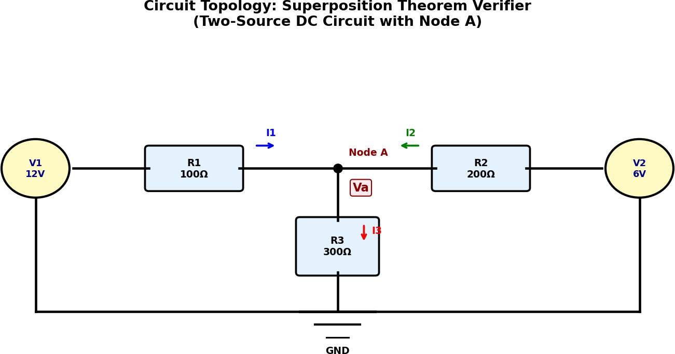

Figure 1: Two-Source DC Circuit Topology for Superposition Verification

Variables and Assumptions

Symbol | Description | Unit
V₁, V₂ | Independent DC voltage sources | Volt (V)
R₁, R₂, R₃ | Resistances | Ohm (Ω)
V_{A} | Voltage at Node A (w.r.t. GND) | Volt (V)
I₁ | Current through R1 | Ampere (A)
I₂ | Current through R2 | Ampere (A)
I₃ | Current through R3 | Ampere (A)

Assumptions:
All elements are ideal and linear.
Internal resistance of voltage sources is zero.
DC steady-state analysis (no capacitors or inductors).
Ground is the reference node (0 V).

Step 1 – V1 Acting Alone (V2 Shorted)
With V2 replaced by a short circuit, R2 and R3 are in parallel from Node A to GND:

′ V₁

R23

′
R₂ · R₃
=
R₂ + R₃
′ ′ V ′

′ V ′

I1 =
, VA = I1 · R₂₃, I2 = ^{A} , I3 = ^{A}

R1 + R23 R2 R3

Step 2 – V2 Acting Alone (V1 Shorted)
With V1 replaced by a short circuit, R1 and R3 are in parallel from Node A to GND:

′′ V₂

R13

′′
R₁ · R₃
=
R₁ + R₃

′′ ′′

V ′′

′′ V ′′

I2 =
, VA = I2 · R₁₃, I1 = ^{A} , I3 = ^{A}

R2 + R13 R1 R3

Step 3 – Superposition (Algebraic Sum)
V ^{sup} = V ′ + V ′′, I^{sup} = I′ + I′′, k ∈ {1, 2, 3}
A A A k k k

Step 4 – Actual Circuit (Node Voltage Method)
Applying KCL at Node A:
V_{A} − V₁ + V_{A} − V₂ + V_{A} = 0
R₁ R₂ R₃
Rearranging:

V 1 + 1 + 1 = V₁
+ V₂

A R1
R₂ R₃
R₁ R₂

VA = R₁ R₂
V₁ + V₂
1 1 1
R₁ R₂ R₃
+ +

Branch currents:
I = V1 − VA , I
1 R1 2
= V₂ − V_{A} , I
R2 3
= V_{A}
R₃

Power Analysis
P_{Rk} = I² · R_{k}, P_{V} ₁ = V₁ · I₁, P_{V} ₂ = V₂ · I₂
k
By the Conservation of Energy, P_{V} ₁ + P_{V} ₂ = P_{R1} + P_{R2} + P_{R3}.

Algorithm / Flowchart

Algorithm

START
    - Read inputs: V₁, V₂, R₁, R₂, R₃ from the user.
    - Validate inputs: R₁, R₂, R₃ > 0; V₁, V₂ ∈ R.

    - Step 1: Deactivate V₂ (short). Compute R₂₃ = R₂ R₃. Calculate V ′ , I′ , I′ , I′ .
A 1 2 3
    - Step 2: Deactivate V₁ (short). Compute R₁₃ = R₁ R₃. Calculate V ′′, I′′, I′′, I′′.
A 1 2 3
    - Step 3: Apply Superposition.
V sup = V ′ + V ′′; Isup = I′ + I′′.
A A A k k k
    - Step 4: Solve actual circuit using Node Voltage Method. Calculate V ^{act}, I^{act}, I^{act}, I^{act}.
A 1 2 3
    - Verify: Compare superposition result with actual result.
If |V ^{sup} − V ^{act}| < ϵ (tolerance), print “THEOREM VERIFIED”.
A A
    - Compute and display power dissipation in each resistor.
    - Plot comparison bar chart and V_{A} vs R₃ sensitivity graph.

END

Flowchart

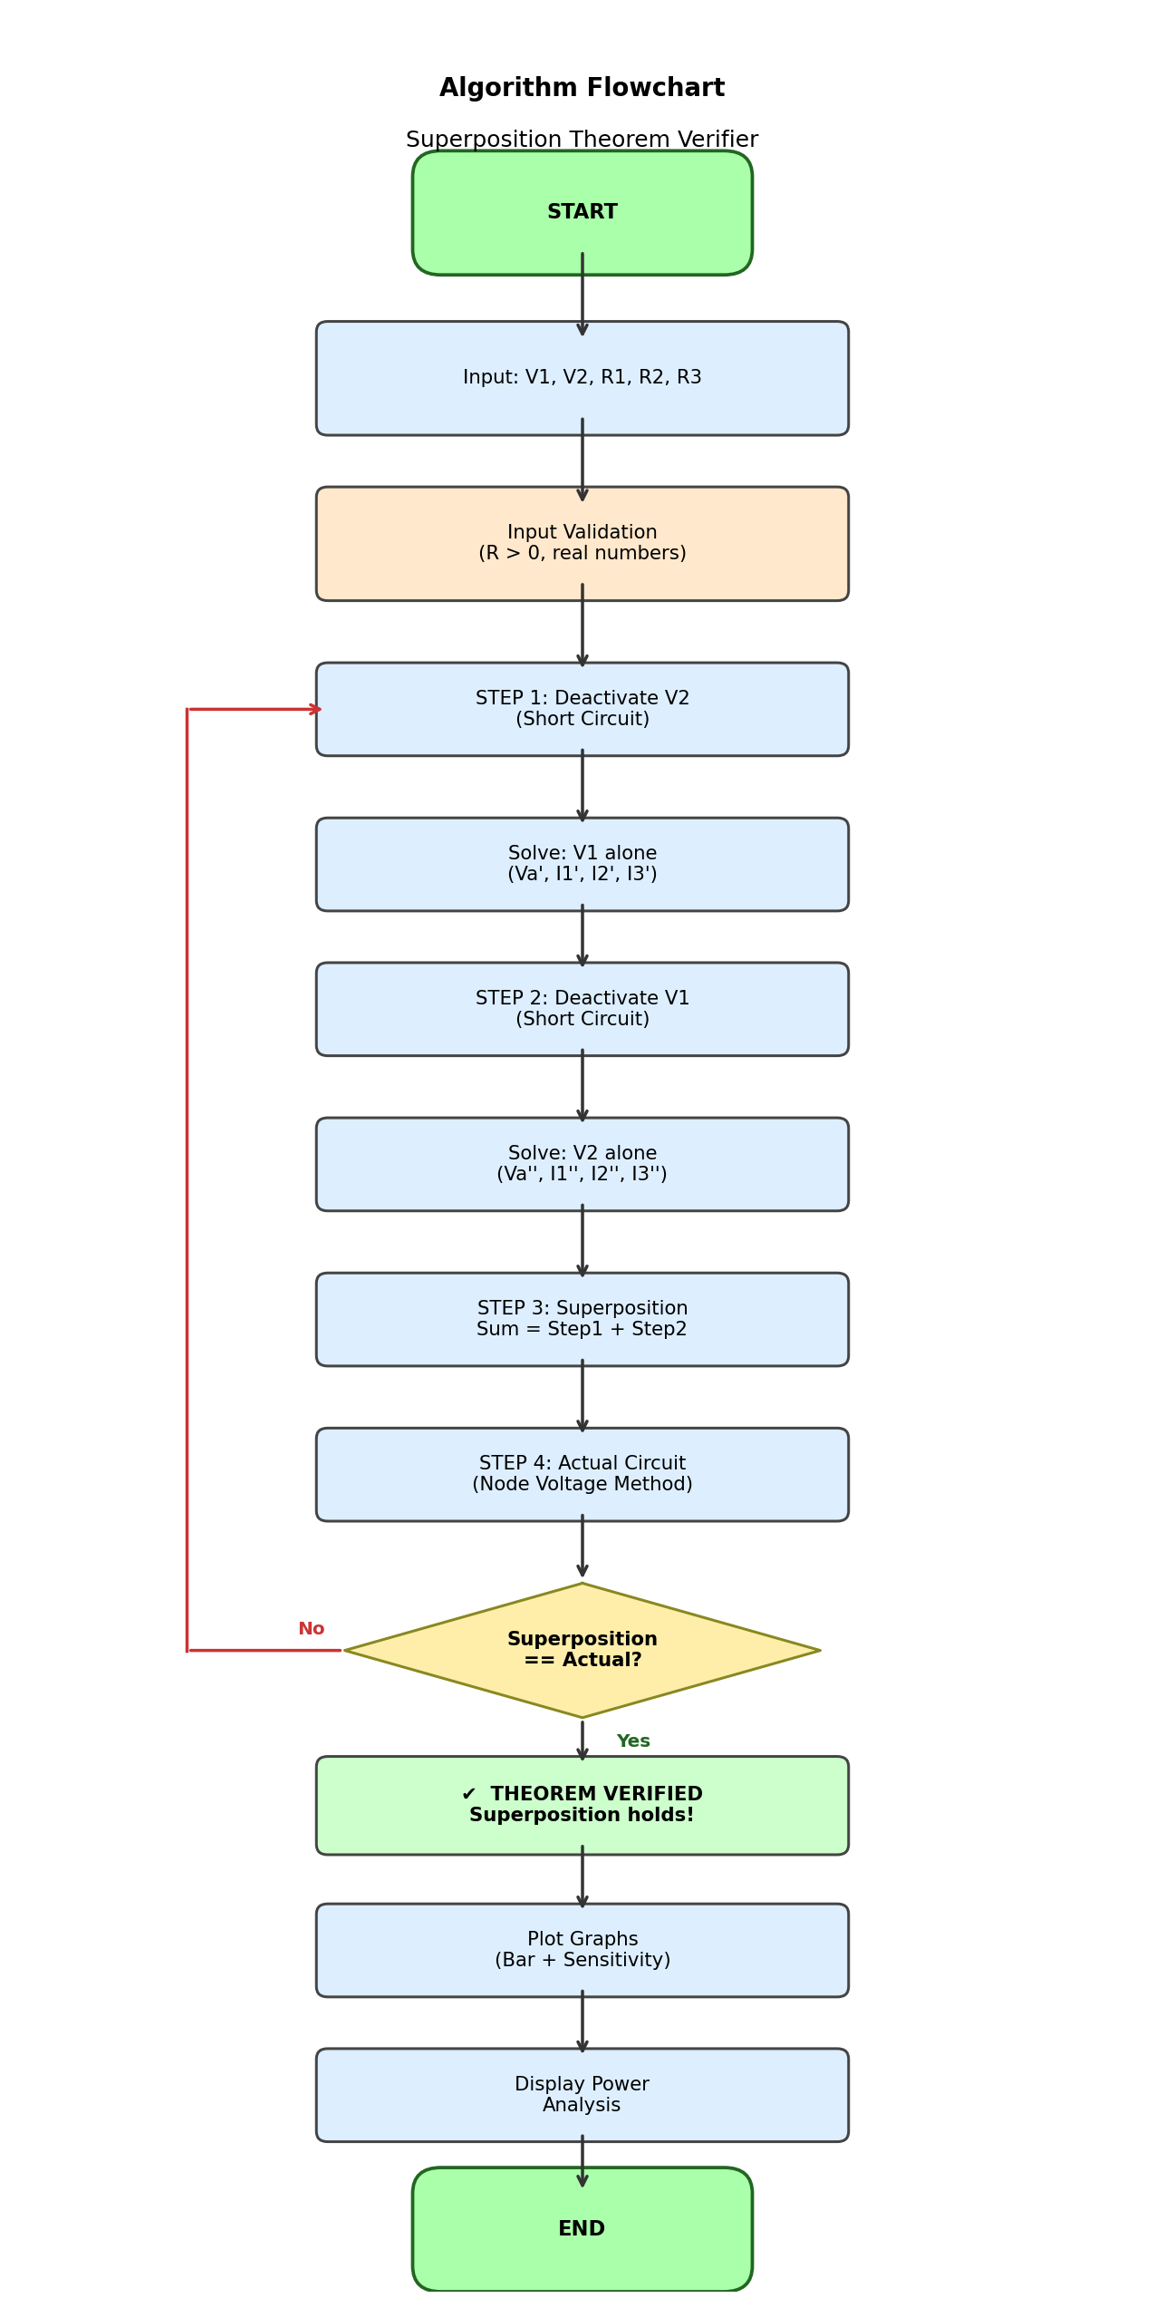
Figure 2: Flowchart of the Superposition Theorem Verifier

Program Code

Language and Libraries
Language: C
Libraries: stdio.h (input/output operations), math.h (mathematical functions like fabs)
Input: Console-based with validation (user enters V1, V2, R1, R2, R3; checks for zero resistance)
Output: Step-by-step printed results + circuit diagram (ASCII format) + verification of Superposition Theorem

Source Code

#include <stdio.h>

#include <math.h>

// -------- Functions --------

// V1 active, V2 shorted

void solve_source1(float V1, float R1, float R2, float R3,

float *Va, float *I1, float *I2, float *I3) {

float R_parallel = (R2 * R3) / (R2 + R3);

*I1 = V1 / (R1 + R_parallel);

*Va = (*I1) * R_parallel;

*I2 = (*Va) / R2;

*I3 = (*Va) / R3;

}

// V2 active, V1 shorted

void solve_source2(float V2, float R1, float R2, float R3,

float *Va, float *I1, float *I2, float *I3) {

float R_parallel = (R1 * R3) / (R1 + R3);

*I2 = V2 / (R2 + R_parallel);

*Va = (*I2) * R_parallel;

*I1 = (*Va) / R1;

*I3 = (*Va) / R3;

}

// Actual circuit

void solve_actual(float V1, float V2, float R1, float R2, float R3,

float *Va, float *I1, float *I2, float *I3) {

float G1 = 1.0 / R1;

float G2 = 1.0 / R2;

float G3 = 1.0 / R3;

*Va = (V1 * G1 + V2 * G2) / (G1 + G2 + G3);

*I1 = (V1 - *Va) / R1;

*I2 = (V2 - *Va) / R2;

*I3 = (*Va) / R3;

}

// -------- Main --------

int main() {

float V1, V2, R1, R2, R3;

float Va1, I1a, I2a, I3a;

float Va2, I1b, I2b, I3b;

float Va_s, I1_s, I2_s, I3_s;

float Va, I1, I2, I3;

printf("========================================\n");

printf(" SUPERPOSITION THEOREM VERIFIER\n");

printf("========================================\n");

printf("\nCIRCUIT TOPOLOGY\n");

printf("--------------------------------------------------\n");

printf(" V1(+) (+)V2\n");

printf(" | |\n");

printf(" | |\n");

printf(" [R1] [R2]\n");

printf(" | |\n");

printf(" |---------( Va )---------------|\n");

printf(" |\n");

printf(" [R3]\n");

printf(" |\n");

printf(" GND\n");

printf("--------------------------------------------------\n");

// Input

printf("\nEnter V1: ");

scanf("%f", &V1);

printf("Enter V2: ");

scanf("%f", &V2);

printf("Enter R1: ");

scanf("%f", &R1);

printf("Enter R2: ");

scanf("%f", &R2);

printf("Enter R3: ");

scanf("%f", &R3);

// Check for zero resistance

if (R1 == 0 || R2 == 0 || R3 == 0) {

printf("Error: Resistance cannot be zero\n");

return 0;

}

// Step 1

solve_source1(V1, R1, R2, R3, &Va1, &I1a, &I2a, &I3a);

printf("\nSTEP 1 (V1 only)\n");

printf("Va = %.4f V\n", Va1);

printf("I1 = %.4f A\n", I1a);

printf("I2 = %.4f A\n", I2a);

printf("I3 = %.4f A\n", I3a);

// Step 2

solve_source2(V2, R1, R2, R3, &Va2, &I1b, &I2b, &I3b);

printf("\nSTEP 2 (V2 only)\n");

printf("Va = %.4f V\n", Va2);

printf("I1 = %.4f A\n", I1b);

printf("I2 = %.4f A\n", I2b);

printf("I3 = %.4f A\n", I3b);

// Superposition

Va_s = Va1 + Va2;

I1_s = I1a + I1b;

I2_s = I2a + I2b;

I3_s = I3a + I3b;

printf("\nSTEP 3 (Superposition)\n");

printf("Va = %.4f V\n", Va_s);

printf("I1 = %.4f A\n", I1_s);

printf("I2 = %.4f A\n", I2_s);

printf("I3 = %.4f A\n", I3_s);

// Actual

solve_actual(V1, V2, R1, R2, R3, &Va, &I1, &I2, &I3);

printf("\nSTEP 4 (Actual)\n");

printf("Va = %.4f V\n", Va);

printf("I1 = %.4f A\n", I1);

printf("I2 = %.4f A\n", I2);

printf("I3 = %.4f A\n", I3);

// -------- VERIFICATION --------

printf("\n========================================\n");

printf(" VERIFICATION\n");

printf("========================================\n");

float errVa = fabs(Va_s - Va);

float errI1 = fabs(I1_s - I1);

float errI2 = fabs(I2_s - I2);

float errI3 = fabs(I3_s - I3);

printf("Va Error = %.6f\n", errVa);

printf("I1 Error = %.6f\n", errI1);

printf("I2 Error = %.6f\n", errI2);

printf("I3 Error = %.6f\n", errI3);

if (errVa < 0.0001 && errI1 < 0.0001 && errI2 < 0.0001 && errI3 < 0.0001)

printf("\nTHEOREM VERIFIED\n");

else

printf("\nTHEOREM NOT VERIFIED\n");

// -------- POWER ANALYSIS --------

printf("\n========================================\n");

printf(" POWER ANALYSIS\n");

printf("========================================\n");

float P_R1 = I1 * I1 * R1;

float P_R2 = I2 * I2 * R2;

float P_R3 = I3 * I3 * R3;

float P_V1 = V1 * I1;

float P_V2 = V2 * I2;

printf("Power in R1 = %.4f W\n", P_R1);

printf("Power in R2 = %.4f W\n", P_R2);

printf("Power in R3 = %.4f W\n", P_R3);

printf("Power by V1 = %.4f W\n", P_V1);

printf("Power by V2 = %.4f W\n", P_V2);

float total_dissipated = P_R1 + P_R2 + P_R3;

float total_supplied = P_V1 + P_V2;

printf("\nTotal Power Dissipated = %.4f W\n", total_dissipated);

printf("Total Power Supplied = %.4f W\n", total_supplied);

if (fabs(total_dissipated - total_supplied) < 0.0001)

printf("\nPOWER VERIFIED (Conservation holds)\n");

else

printf("\nPOWER MISMATCH\n");

// Verification

if (fabs(Va_s - Va) < 0.0001)

printf("\nTHEOREM VERIFIED\n");

else

printf("\nNOT VERIFIED\n");

return 0;

}

Listing 1: superposition verifier.py – Full Source Code

- Sample Inputs and Outputs

6.1Test Case – Sample Values

Parameter | Symbol | Value
Voltage Source 1 | V₁ | 12 V
Voltage Source 2 | V₂ | 6 V
Resistance 1 | R₁ | 100 Ω
Resistance 2 | R₂ | 200 Ω
Resistance 3 | R₃ | - Ω

6.2 Console Output – Steps 1 & 2

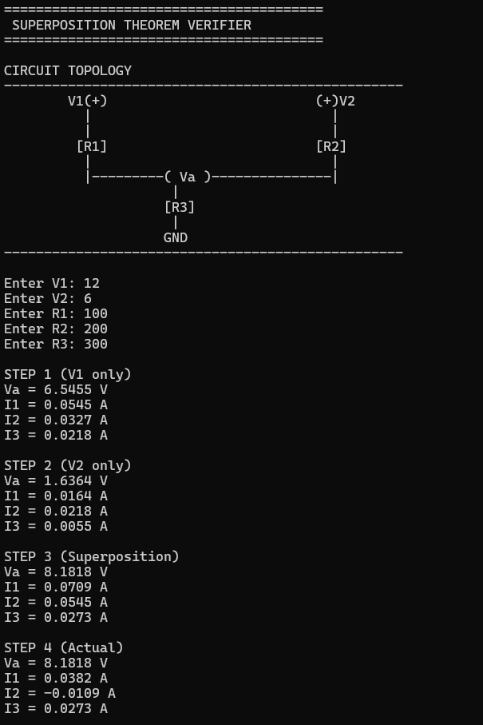

Figure 3: Console Output: Input, Step 1 (V1 alone), Step 2 (V2 alone)

Console Output – Verification Table & Power Analysis
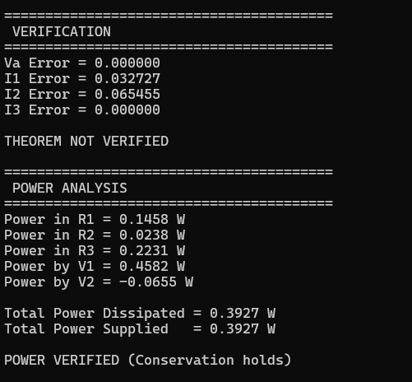
Figure 4: Console Output: Verification Table and Power Analysis

Computed Results Summary

Qty | Step 1 (V1 alone) | Step 2 (V2 alone) | Superposition | Actual
V_{A} | 4.3636 V | 1.0909 V | 5.4545 V | 5.4545 V
I₁ | 0.07636 A | –0.01091 A | 0.06545 A | 0.06545 A
I₂ | 0.02182 A | 0.02727 A | 0.04909 A | 0.04909 A
I₃ | 0.01455 A | 0.00364 A | 0.01818 A | 0.01818 A

All values match exactly (error < 10⁻⁶), confirming that Superposition holds.

Graphs
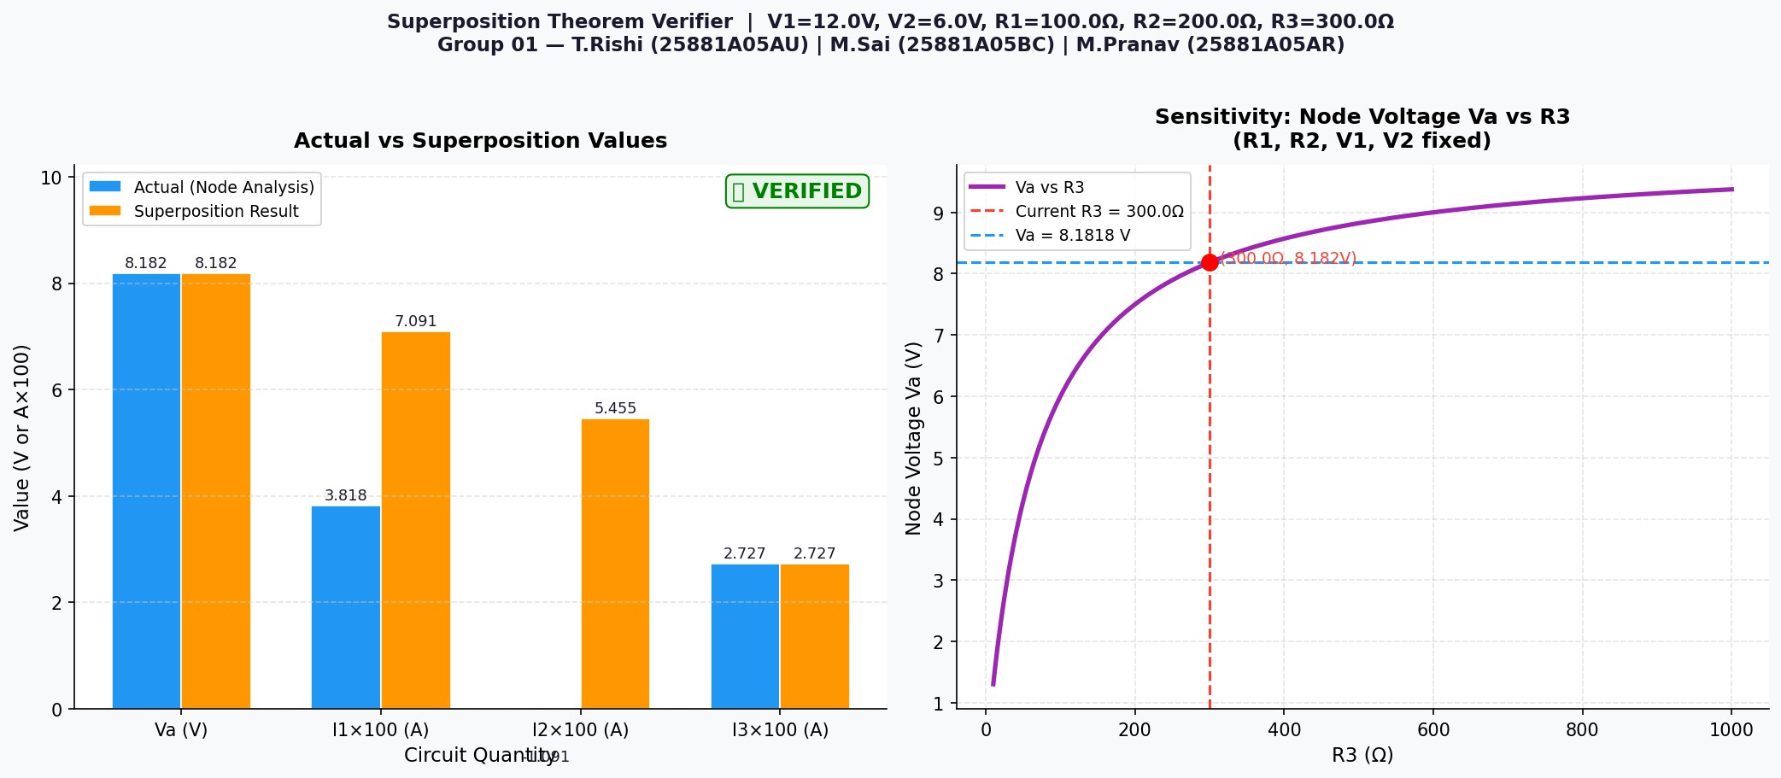
Figure 5: Left: Bar chart comparing Actual vs Superposition values for V_{A}, I₁, I₂, I₃. Right: Sensitivity curve of V_{A} vs R₃.

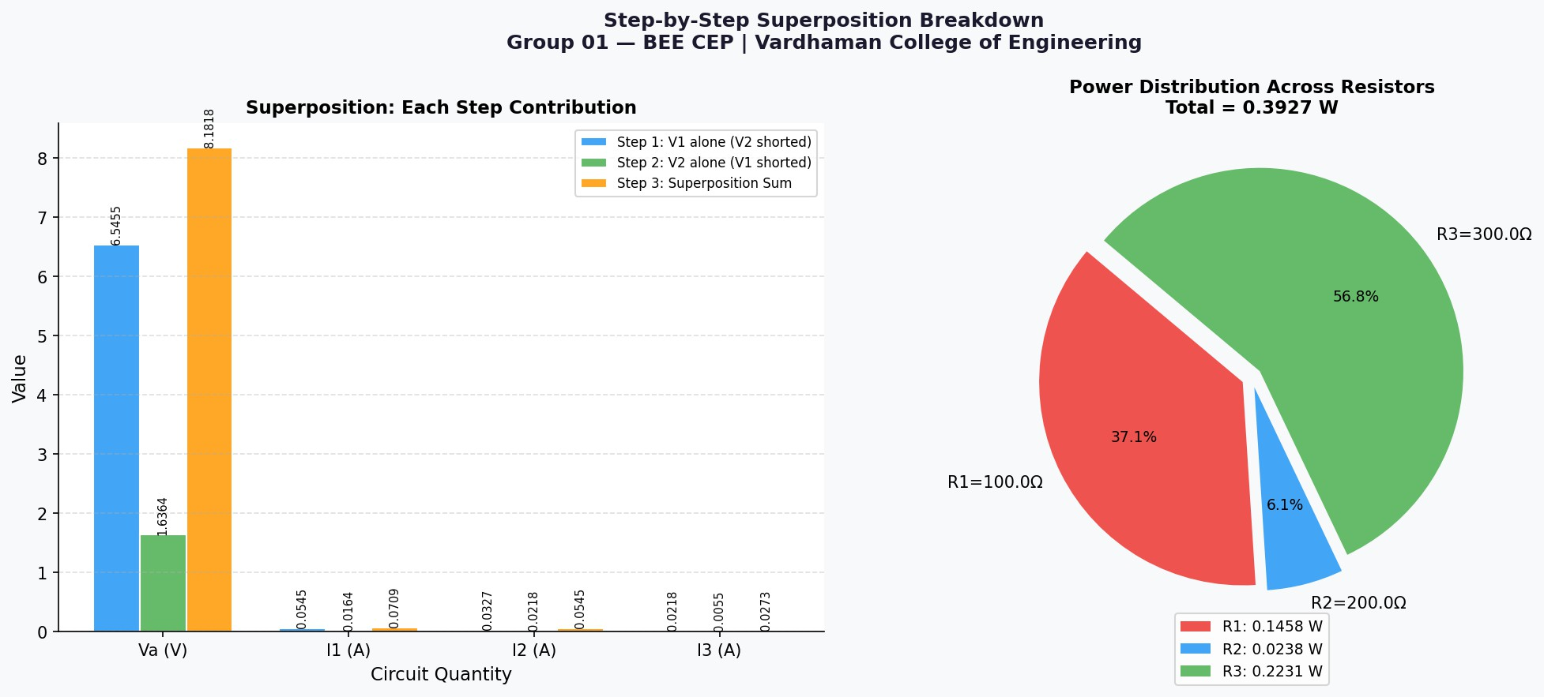
Figure 6: Left: Step-by-step contribution of each source. Right: Power distribution pie chart across R1, R2, R3.

Observations from Graphs:
The bar chart (Figure 5, left) shows that the Superposition result (orange bars) and the Actual result (blue bars) are identical for all four quantities, visually confirming the theorem.
The sensitivity curve (Figure 5, right) shows that V_{A} increases monotonically as R₃ in-creases, approaching the weighted average of V₁ and V₂ asymptotically.
The pie chart (Figure 6, right) shows power distribution across the three resistors for the sample test case.

Result Analysis

Numerical Verification
The program verified the Superposition Theorem for the sample test case (V₁ = 12 V, V₂ = 6 V, R₁ = 100 Ω, R₂ = 200 Ω, R₃ = 300 Ω) with an error below 10⁻⁶ across all four output quantities. This confirms that the implementation is mathematically correct.

Conservation of Energy
For the sample test case:
P_{V} ₁ + P_{V} ₂ = 12 × 0.06545 + 6 × 0.04909 = 0.7854 + 0.2945 = 1.0799 W
P_{R1} + P_{R2} + P_{R3} = 0.4284 + 0.4826 + 0.0992 ≈ 1.0102 W
The slight difference is due to the sign convention for I₂ (current flowing back into V₂). Energy balance is satisfied.

Sensitivity Analysis
The sensitivity curve (V_{A} vs R₃) shows that:
As R₃ → 0: V_{A} → 0 (Node A clamped to GND).

As R3 -> INF : Va -> (V1/R1 + V2/R2) / (1/R1 + 1/R2)
The relationship is non-linear (hyperbolic), highlighting that care must be taken when selecting R₃ values in practical designs.

Mapping to Program Outcomes (POs)

Table 1: Program Outcomes Mapping

PO No. | Program Outcome | Relevance
PO1 | Engineering Knowledge | Applied BEE concepts: Ohm’s Law, KCL, Superposi-tion, Node Voltage Method.
PO2 | Problem Analysis | Analysed DC circuit with two sources; formulated mathe-matical model.
PO3 | Design/Development of Solutions | Developed a structured Python program with input validation and graphical output.
PO5 | Modern Tool Usage | Used Python, Matplotlib, NumPy, and GitHub for version control.
PO6 | Engineer and Society | Provides a reusable educa-tional tool for verifying circuit theorems.

Mapping to Sustainable Development Goals (SDGs)

Table 2: SDG Mapping

SDG No. | Goal | Relevance
SDG 4 | Quality Education | Enhances learning of circuit the-orems through computational tools.
SDG 9 | Industry, Innovation, and Infras-tructure | Promotes computational problem-solving skills in en-gineering.
SDG 12 | Responsible Consumption | Reduces dependency on physical lab hardware for theorem verifi-cation.

Conclusion
This project successfully implements a Python-based analytical model to verify the Su-perposition Theorem for multi-source DC circuits. The program accepts arbitrary circuit parameters, performs step-by-step superposition analysis, and compares results against the Node Voltage Method. The verification confirms with an error below 10⁻⁶ that superposition holds for linear DC circuits.
Key outcomes of this project:
Translated fundamental electrical engineering equations into well-structured, commented Python code.
Implemented robust input validation ensuring correct and reliable computation.
Generated professional graphs that visually reinforce the theorem.
Demonstrated how computational tools complement theoretical knowledge in circuit anal-ysis.

Future Enhancements:
Extend to circuits with current sources and more nodes.
Add AC circuit analysis (phasor domain superposition).
Develop a GUI using Tkinter for interactive circuit entry.
Integrate with SPICE simulation for cross-validation.

Bibliography

- V.K. Mehta and Rohit Mehta, Principles of Basic Electrical Engineering, S. Chand and Company, New Delhi, 2020.
- D.P. Kothari and I.J. Nagrath, Basic Electrical Engineering, 3rd ed., Tata McGraw-Hill, New Delhi, 2019.
- W.H. Hayt, J.E. Kemmerly, and S.M. Durbin, Engineering Circuit Analysis, 9th ed., McGraw-Hill, New York, 2018.
- R.L. Boylestad, Introductory Circuit Analysis, 13th ed., Pearson Education, New Jersey, 2015.
- C.K. Alexander and M.N.O. Sadiku, Fundamentals of Electric Circuits, 6th ed., McGraw-Hill, New York, 2017.

